3 Tables Join

3 Tables Inner join:

create table continent_master

(ContinentID Varchar(15) Primary Key,

Name_of_Continent Varchar(20),

Continent_Amount_Allocated Int

);

create table country_master

(ContinentID Varchar(15) references continent_master,

CountryID Varchar(15) Primary Key,

Name_of_Country Varchar(50),

Country_Amount_Allocated Int

);

create table transactions

(TrID Varchar(10),

CountryID Varchar(15) References country_master,

Name_of_City Varchar(40),

Amount_Spent Int

);

Insert into continent_master values('Con1', 'Asia', 50000);

Insert into continent_master values('Con2', 'Africa', 30000);

Insert into continent_master values('Con3', 'Europe', 80000);

Insert into continent_master values('Con4', 'Australia', 85000);

Insert into continent_master values('Con5', 'Americas', 90000);

---------------------------------------------------------------------------------

Insert into country_master values('Con1','Cu1','India',10000);

Insert into country_master values('Con1','Cu2','China',20000);

Insert into country_master values('Con1','Cu3','UAE',15000);

Insert into country_master values('Con2','Cu4','Sudan',15000);

Insert into country_master values('Con2','Cu5','Kenya',15000);

Insert into country_master values('Con3','Cu6','France',20000);

Insert into country_master values('Con3','Cu7','Germany',20000);

Insert into country_master values('Con3','Cu8','Italy',20000);

Insert into country_master values('Con4','Cu9','Australia', 12000);

Insert into country_master values('Con4','Cu10','New Zealand', 9000);

Insert into country_master values('Con5','Cu11','USA', 50000);

Insert into country_master values('Con5','Cu12','Canada', 35000);

Insert into country_master values('Con5','Cu13','Brazil', 20000);

Insert into country_master values('Con5','Cu14','Argentina', 15000);

---------------------------------------------------------------------------------

Insert into Transactions values('T1', 'Cu1','Mumbai',200);

Insert into Transactions values('T2', 'Cu1','Mumbai',150);

Insert into Transactions values('T3', 'Cu1','Delhi',50);

Insert into Transactions values('T4', 'Cu1','Delhi',70);

Insert into Transactions values('T5','Cu2','Beijing',300);

Insert into Transactions values('T6','Cu2','Beijing',200);

Insert into Transactions values('T7','Cu2','Shanghai',700);

Insert into Transactions values('T8','Cu2','Shanghai',900);

Insert into Transactions values('T9','Cu3','Dubai',1000);

Insert into Transactions values('T10','Cu3','Dubai',1500);

Insert into Transactions values('T11', 'Cu3','Abu Dhabi',800);

Insert into Transactions values('T12', 'Cu3','Abu Dhabi',600);

Insert into Transactions values('T13','Cu4','Khartoum',80);

Insert into Transactions values('T14','Cu4','Khartoum',20);

Insert into Transactions values('T15','Cu4','Kassala',50);

Insert into Transactions values('T16','Cu4','Kassala',10);

Insert into Transactions values('T17','Cu5','Nairobi',90);

Insert into Transactions values('T18','Cu5','Nairobi',70);

Insert into Transactions values('T19','Cu5','Mombasa', 300);

Insert into Transactions values('T20','Cu5','Mombasa', 2000);

Insert into Transactions values('T21','Cu6','Paris', 900);

Insert into Transactions values('T22','Cu6','Paris', 1100);

Insert into Transactions values('T23','Cu6','Lyon', 2100);

Insert into Transactions values('T24','Cu6','Lyon', 200);

Insert into Transactions values('T25','Cu7','Berlin', 500);

Insert into Transactions values('T26','Cu7','Berlin', 700);

Insert into Transactions values('T27','Cu7','Munich', 1500);

Insert into Transactions values('T28','Cu7','Munich', 1700);

Insert into Transactions values('T29','Cu8','Rome', 3000);

Insert into Transactions values('T30','Cu8','Rome', 2000);

Insert into Transactions values('T31','Cu8','Milan', 500);

Insert into Transactions values('T32','Cu8','Milan', 800);

Insert into Transactions values('T33','Cu9','Sydney', 2800);

Insert into Transactions values('T34','Cu9','Sydney', 3100);

Insert into Transactions values('T35','Cu9','Melbourne', 1400);

Insert into Transactions values('T36','Cu9','Melbourne', 2400);

Insert into Transactions values('T37','Cu10','Auckland', 600);

Insert into Transactions values('T38','Cu10','Auckland', 800);

Insert into Transactions values('T39','Cu10','Wellington', 2100);

Insert into Transactions values('T40','Cu10','Wellington', 2700);

Insert into Transactions values('T41','Cu11','Sand City', 5000);

Insert into Transactions values('T42','Cu11','Sand City', 6000);

Insert into Transactions values('T43','Cu11','Dublin', 2000);

Insert into Transactions values('T44','Cu11','Dublin', 1000);

Insert into Transactions values('T45','Cu12','Toronto', 2200);

Insert into Transactions values('T46','Cu12','Toronto', 3300);

Insert into Transactions values('T47','Cu12','Ottawa', 2100);

Insert into Transactions values('T48','Cu12','Ottawa', 1300);

Insert into Transactions values('T49','Cu13','Sao Paulo', 900);

Insert into Transactions values('T50','Cu13','Sao Paulo', 400);

Insert into Transactions values('T51','Cu13','Rio de Janeiro', 700);

Insert into Transactions values('T52','Cu13','Rio de Janeiro', 800);

Insert into Transactions values('T53','Cu14','Buenos Aires', 200);

Insert into Transactions values('T54','Cu14','Buenos Aires', 400);

Insert into Transactions values('T55','Cu14','Rosario', 2300);

Insert into Transactions values('T56','Cu14','Rosario', 4400);

**Inner Join of the above 3 tables:**

Select tr.trID,

con.Name_Of_Continent,

cou.Name_of_Country,

tr.Name_of_City,

con.Continent_Amount_Allocated,

cou.Country_Amount_Allocated,

tr.Amount_Spent

from continent_master as con Join country_master as cou

on con.ContinentID = cou.ContinentID

Join transactions tr

on cou.CountryID = tr.CountryID;

Now let’s create a copy of Transactions table and add records from that table in the new table Trasactions**2** excluding records of Mumbai and Delhi

Create table Transactions2

select *

from Transactions

where Name_of_City Not In ('Mumbai','Delhi');

Let’s give the same inner join on the 3 tables, but this the 3rd table is Transactions**2**

Select tr.trID,

con.Name_Of_Continent,

cou.Name_of_Country,

tr.Name_of_City,

con.Continent_Amount_Allocated,

cou.Country_Amount_Allocated,

tr.Amount_Spent

from continent_master as con Join country_master as cou

on con.ContinentID = cou.ContinentID

Join transactions**2** tr

on cou.CountryID = tr.CountryID; -- It shows the 52 matching rows

**Now, let’s give Left Outer join for the first 2 tables’ join, i.e. Continent_Master and Country_Master tables.**

Select tr.trID,

con.Name_Of_Continent,

cou.Name_of_Country,

tr.Name_of_City,

con.Continent_Amount_Allocated,

cou.Country_Amount_Allocated,

tr.Amount_Spent

from continent_master as con **Left Outer Join** country_master as cou

on con.ContinentID = cou.ContinentID

Join transactions**2** tr

on cou.CountryID = tr.CountryID; -- No change, still it shows the same 52 matching rows

**The output is same as that of inner join because all the Continent_IDs are matching in both the tables.**

**After this, let’s give** **Left Outer join before the 3rd table and default inner join for the first 2 tables.**

Select tr.trID,

con.Name_Of_Continent,

cou.Name_of_Country,

tr.Name_of_City,

con.Continent_Amount_Allocated,

cou.Country_Amount_Allocated,

tr.Amount_Spent

from continent_master as con **Inner Join** country_master as cou

on con.ContinentID = cou.ContinentID

**Left Outer Join** transactions**2** tr

on cou.CountryID = tr.CountryID; -- Now it shows one additional record of country India! Totally 53 rows

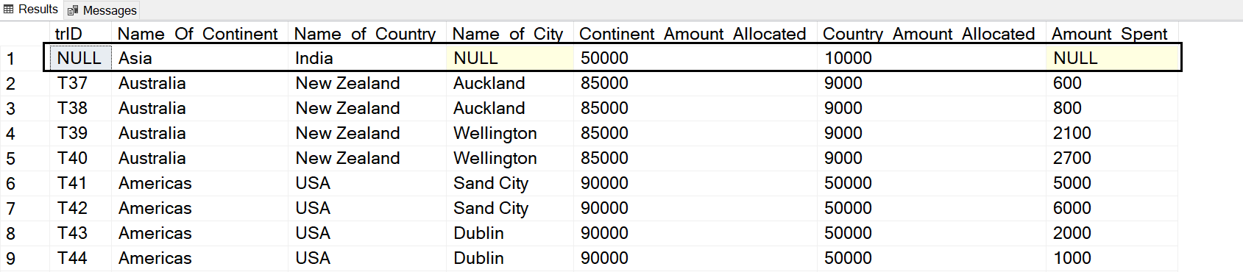

**Business Meaning 🡪 So, it means that when we give the Left outer join before the 3rd table, i.e. Transactions2 table then we understand that for India there are no transactions.**

We will create one more copy of Transactions tale. The name of that table will be Transactions**3**. In this new table will not include any record from Africa continent.

Create table Transactions3

as

select *

from Transactions

where Name_of_City Not In ('Khartoum','Kassala','Nairobi','Mombasa');

Now we will have the same 3 tables join, but this time the 3rd table will be Transactions**3**.

Select tr.trID,

con.Name_Of_Continent,

cou.Name_of_Country,

tr.Name_of_City,

con.Continent_Amount_Allocated,

cou.Country_Amount_Allocated,

tr.Amount_Spent

from continent_master as con **Inner Join** country_master as cou

on con.ContinentID = cou.ContinentID

**Left Outer Join** transactions**3** tr

on cou.CountryID = tr.CountryID;

Totally it shows 50 rows with the additional 2 records of Sudan and Kenya from Africa continent having null entries for transaction table columns as shown next 🡪

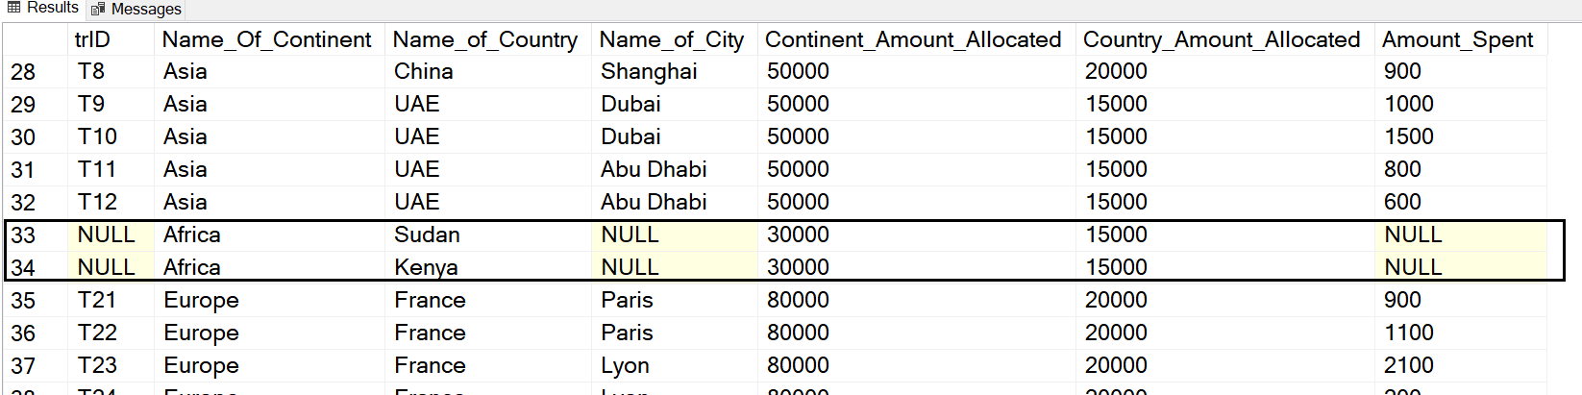

Now, let’s add one more continent record in the main master table Continent_Master

Insert into continent_master values('Con6', 'Oceania', 50000);

**Right now there are no records for Oceania in the Country_Master (i.e. 2nd table) and Transactions (i.e. 3rd table).**

Select tr.trID,

con.Name_Of_Continent,

cou.Name_of_Country,

tr.Name_of_City,

con.Continent_Amount_Allocated,

cou.Country_Amount_Allocated,

tr.Amount_Spent

from continent_master as con **Left Outer Join** country_master as cou

on con.ContinentID = cou.ContinentID

Inner Join transactions tr

on cou.CountryID = tr.CountryID; –- 56 rows

-- The additional record of Oceania is NOT shown

-- Because even if the Left join is there in the first 2 tables, still inner join is there for the 3rd table

-- So the effect gets nullified

To get the additional record we have to mention **Left Outer Join** before the 3rd table as well!!

Select tr.trID,

con.Name_Of_Continent,

cou.Name_of_Country,

tr.Name_of_City,

con.Continent_Amount_Allocated,

cou.Country_Amount_Allocated,

tr.Amount_Spent

from continent_master as con **Left Outer Join** country_master as cou

on con.ContinentID = cou.ContinentID

**Left Outer Join** transactions tr

on cou.CountryID = tr.CountryID; -- 57 rows!!!

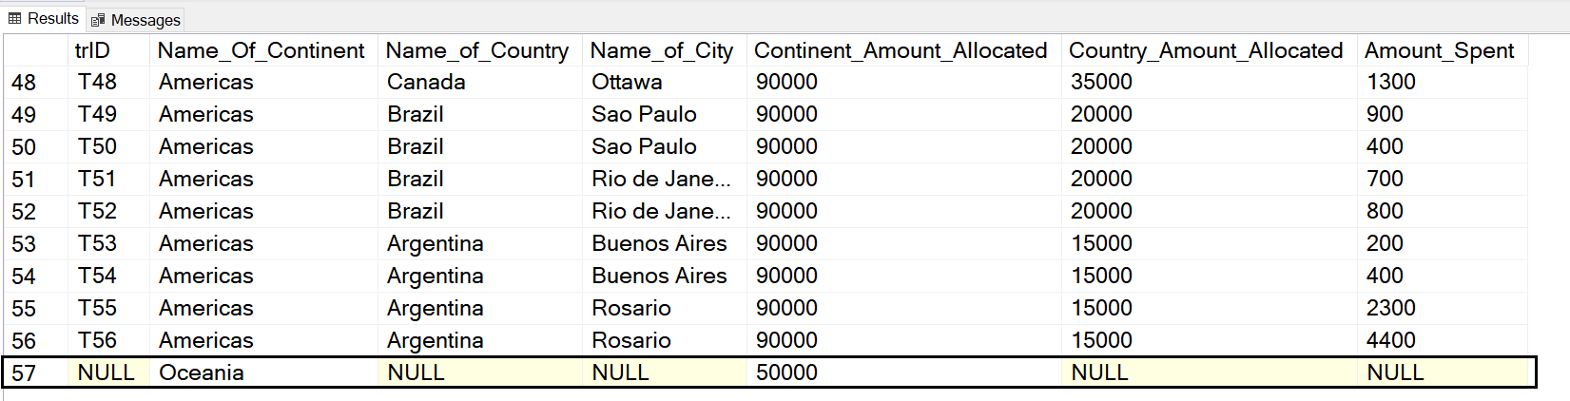

**Conclusion 🡪** When multiple tables are involved in joins and we want to include all the records from the first main master table then Left outer Join needs to be mentioned every time before joining with the next table.